|  |
| --- |
|  |
|  |  |

**Professor Panic: The Academic Exodus**

User Manual

Version 1.1.0

12/01/2023

|  |
| --- |
|  |
|  |  |

**Professor Panic: The Academic Exodus**

**User’s Manual**

**12/01/2023**

**WESTERN NEW ENGLAND UNIVERSITY**

**CPE -425, 525 SOFTWARE ENGINEERING**

**Team#1 Project**

DOCUMENT APPROVALS

|  |  |  |
| --- | --- | --- |
| **NAME** | **SIGNATURE** | **DATE** |
| David Melanson (Project Lead) |  |  |
| Kalyan Bhagavan |  |  |
| Matthew Dingman |  |  |
| Philip Brehart |  |  |
| Logan Paranto |  |  |
| Sydney Adams-Jones |  |  |

DOCUMENT CONTROL / REVISION HISTORY

|  |  |
| --- | --- |
| **TITLE** | User Manual |
| **REPOSITORY LOCATION** | GitHub |
| **URL** | https://github.com/PJB01/Academic-Exodus |

|  |  |  |  |
| --- | --- | --- | --- |
| **Date** | **Version** | **Description** | **Author** |
| 11/01/2023 | 1.0.0 | Initial Draft | KBT |
| 12/01/2023 | 1.1.0 | Screenshots added, minor revisions | All |
|  |  |  |  |
|  |  |  |  |
|  |  |  |  |
|  |  |  |  |
|  |  |  |  |
|  |  |  |  |
|  |  |  |  |
|  |  |  |  |

Table of Contents

Section 1: Introduction 3

About "Professor: Academic Exodus 3

Game Highlights 3

Game Features 3

System Requirements 3

Installation Instructions 4

Section 2: Getting Started 4

Launching the Game 4

Main Menu Navigation 4

Starting a New Game 5

Loading a Saved Game 5

Section 3: Player Controls 6

Keyboard Controls 6

Mouse Controls 7

Customizing Controls 7

Section 4: Gameplay Basics 7

Game Objective 7

Game Overview 8

Player Character 8

Non-Player Characters (NPCs) 8

Combat System 9

Section 5: Graphics and Visuals, and Sound and Audio 9

Graphics and Visuals 9

Graphics Settings 9

Art Style and Design 10

User Interface (UI) 10

Sound and Audio 10

Audio Settings 10

Music and Sound Effects 10

Section 6: Game Interactions and Game Environment 11

Multiple Floors and Building Layout 11

Combat Using the Pencil Icon 11

Switching Between Classrooms and Floors 11

Section 7: Tips and Best Practices 12

Optimization 12

Cross-Platform Development 12

Section 8: Credits and Acknowledgments 13

Game Development Team 13

Special Thanks 13

Section 10: Appendices 13

# Section 1: Introduction

## About "Professor Panic: The Academic Exodus”

"Professor Panic: The Academic Exodus" is a fun game where you use a pencil to go on an adventure in school. Explore different challenges and solve puzzles while facing tough opponents. It's like a journey into the world of learning with a bit of excitement and strategy.

## Game Highlights

**Multi-Floor Gameplay:** Embark on a journey within a multi-floored academic institution, featuring meticulously crafted environments. Explore classrooms, libraries, laboratories, and more as the game progresses.

**Switching Classrooms:** The academic institution is filled with dynamic classrooms. Master the art of switching between classrooms and uncover the secrets of each academic room.

**Combat with a Pencil Icon**: Engage in tactical combat encounters using a pencil icon as a weapon. Strategically face off against foes and use wits to overcome academic adversaries.

## Game Features

* **Engaging Storyline:** Dive into an immersive narrative around the professor to uncover hidden knowledge and solve mysteries within an academic institution.
* **Player Controls:** Navigate the game world using intuitive keyboard, mouse, or gamepad controls. Even customize the control scheme to suit preferences.
* **Game Mechanics**: Encounter a wide range of game mechanics, combat systems, and character progression, keeping the gameplay experience varied and exciting.
* **Stunning Graphics**: Immerse in a visually appealing game world, featuring detailed environments, vibrant art styles, and atmospheric effects.
* **Rich Sound and Audio:** Enjoy an immersive audio experience with an original soundtrack, sound effects, and voiceovers that bring the game to life.

## System Requirements

Before beginning the academic journey, ensure that the gaming system is able to run Python3, has PyGame installed, and has a keyboard, mouse, and audio and visual outputs.

Installation Instructions

To begin academic adventure, follow these installation instructions:

* **Acquire the Game:** Obtain the game installation files through the official website, a digital distribution platform, or a physical copy if available.
* **Installation Process:**
  + If you've downloaded the game online, run the installer executable.
  + Follow the on-screen instructions to select your installation directory and configure any desired settings.
* **Updates and Patches:** After installation, make sure to download and install any available updates or patches to ensure the best gaming experience.
* **Launch the Game**: Once the installation is complete, launch the game from desktop shortcut or start menu.

# Section 2: Getting Started

## Launching the Game

After successfully installing "Professor Panic: Academic Exodus," launching the game is the first step towards academic adventure. Follow these steps to start journey:

1. Desktop Shortcut: If you created a desktop shortcut during the installation process, simply double-click the game's icon on your desktop.

2. Start Menu (Windows):

- Click the Windows Start button.

- Search for "Professor: Academic Exodus" in the search bar.

- Click on the game's entry in the search results.

3. Applications Folder (macOS):

- Open your Applications folder.

- Locate and click on the "Professor: Academic Exodus" application.

## Main Menu Navigation

Upon launching the game, you will be greeted with the main menu (see next page for visual). The main menu is your gateway to various in-game options and features. Here's an overview of what you'll find in the main menu:

* **Play:** Start a new game and begin your academic adventure from the beginning or load a previously saved game file.
* **Options**: Adjust in-game settings, including graphics, audio, controls, and other options to tailor the game to preferences.
* **Quit**: Exit the game and return to your desktop or platform.
* 

## Starting a New Game

If you're eager to begin your adventure, follow these steps to start a new game:

1. **Main Menu**:

- Click on "New Game" in the main menu.

2. **Character Selection**:

- If the game offers character selection, choose your preferred character. Each character may have unique abilities and storylines.

3. **Introduction**: Enjoy the game's opening sequence and introduction that sets the stage for your journey.

**4. Gameplay Tutorial**: Some games offer a tutorial phase to familiarize you with controls and basic mechanics. Follow the tutorial prompts to learn the ropes.

5. **Begin Your Adventure**: Once the introduction and tutorial are complete, you'll find yourself in the game world. Start exploring and immersing yourself in the story.

## Loading a Saved Game

If you've previously saved your progress and wish to continue your adventure, follow these steps to load a saved game:

From **Main Menu**:

1. Click on "Play" in the main menu.

2. Select “Load Game”

3. **Select a Save Slot**:

- Choose a save slot where you've previously saved your game progress.

4. **Continue Playing**:

- Your game will load, and you'll resume from the point where you left off.

# Section 3: Player Controls

In "Professor Panic: The Academic Exodus," mastering player controls is essential for navigating the game world, interacting with characters, and overcoming challenges. This chapter provides an in-depth look at the available control options and how to customize them to suit preferences.

## Keyboard Controls

The default keyboard controls are designed for intuitive gameplay. Here are the primary keyboard controls you'll need to know:

* W, A, S, D: Use these keys to move your character. "W" moves forward, "A" moves left, "S" moves backward, and "D" moves right.
* E: The "E" key is often used for opening inventory, accessing menus, or interacting with the environment.
* Esc (Escape): The "Esc" key opens the in-game menu, allowing you to access settings, save your game, or quit.
* 1-9: These numeric keys may be used to quickly access items or abilities in your inventory.
* Left-Shift: While in game, used to cause the character to “sprint”, increases player movement speed.

## Mouse Controls

In addition to keyboard controls, the mouse is often used for various interactions:

* Left Mouse Button: Click the left mouse button to interact with objects, characters, and perform actions.

## Customizing Controls

If you prefer a different control layout or have a specific gamepad you'd like to use, "Professor: Academic Exodus" may offer control customization options. To customize your controls:

* From Options Menu:
* Access the game's settings menu from the main menu or in-game.
* Controls: Look for the "Controls" section.
* Customize Controls: Depending on the game, you may be able to remap keys, buttons, or sticks to your liking.
* Save Settings: After customizing controls, remember to save settings to apply the changes.

# Section 4: Gameplay Basics

Understanding the fundamental elements of "Professor Panic: The Academic Exodus" is essential for an enjoyable gaming experience. This chapter will explore the core concepts, characters, objectives, and game world, providing a strong foundation for academic adventure.

## Game Objective

"Professor Panic: The Academic Exodus" is an adventure game with diverse objectives. Your primary goal may vary, but it typically revolves around:

* **Academic Pursuits:** As the student, you embark on a journey to solve complex academic puzzles, uncover hidden knowledge, and reveal the secrets of the academic institution.
* **Exploration**: Explore the game world, taking place in Sleith Hall of Western New England with multiple floors and a multitude of unique room environments.
* **Objectives**: Complete objectives that lead to new abilities, unlocking new areas, academic achievements and personal growth.
* **Character Progression:** Improve character's skills, abilities, and knowledge as progress through the game.

## Game Overview

The game world in "Professor Panic: The Academic Exodus" is a rich and immersive environment with diverse locations, each offering unique challenges and opportunities.

* **Academic Institution:** The central setting is the Sleith Hall of Western New England in Springfield, Massachusetts, a place filled with laboratories, classrooms, and mysterious enemies to defeat.
* **NPCs (Non-Player Characters):** Interact with a variety of characters, from fellow students and professors to enigmatic figures who hold the keys to academic secrets.
* **Collectibles and Items:** Throughout the world, you'll encounter collectibles, items, and artifacts that will aid you on your journey.

## Player Character

* **Attributes**: Your character may possess attributes such as intelligence, agility, and charisma that influence their interactions and abilities.
* **Skills**: As you progress, your character can acquire new skills and abilities that are essential for solving puzzles and overcoming obstacles.
* **Progression**: Throughout the game, your character's growth and academic achievements will significantly impact your gameplay.

## Non-Player Characters (NPCs)

"Professor Panic: The Academic Exodus" is populated by a diverse cast of non-player characters, each with their own stories, personalities, and roles in the game world:

* Fellow Students: Interact with other students who may provide information, or assistance on your journey.
* Professors and Instructors: Seek guidance and knowledge from experienced professors who can help you in your academic pursuits.
* Mysterious Figures: Encounter enigmatic characters who hold secrets and challenges that can alter the course of your adventure.

Collectibles and Items

As you explore the academic institution and its surroundings, you'll come across various collectibles and items:

* **Academic Artifacts**: Discover artifacts that allow for new ways of interacting with the environment and tackling challenges.
* **Equipment**: Acquire equipment and items that enhance character's abilities and provide advantages in different situations.

## Combat System

While "Professor Panic: The Academic Exodus" primarily focuses on academic challenges, there may be situations where you need to engage in combat:

* **Combat Scenarios**: Face enemies, obstacles that require combat skills to overcome.
* **Combat Mechanics**: Learn how to attack, defend, and use character abilities effectively during combat.
* **Weapons and Equipment**: Acquire and use weapons, and combat-related items to enhance your combat capabilities.
* **Character Progression:** Your character's growth and skill development also influence your combat abilities.

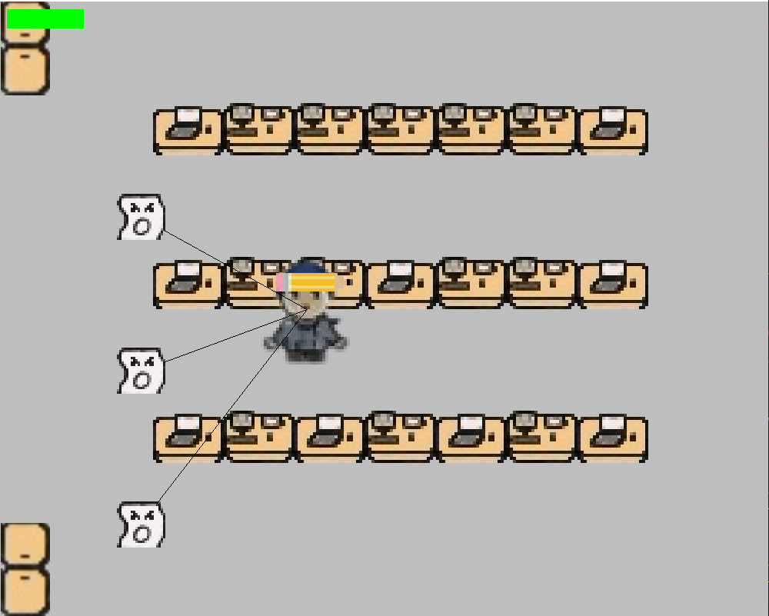

# Section 5: Graphics and Visuals, and Sound and Audio

In "Professor Panic: The Academic Exodus," the quality of graphics and the richness of audio play a vital role in creating an immersive gaming experience. This chapter combines the discussion of both graphics and visuals, as well as sound and audio in the game.

## Graphics and Visuals

The visual aspect of a game contributes significantly to its atmosphere and overall appeal.

## Graphics Settings

* **Resolution**: Adjust the screen resolution to optimize the game's visual quality and performance based on monitor and hardware.

## Art Style and Design

"Professor Panic: The Academic Exodus" boasts a unique and captivating art style. This contributes to the game's atmosphere and storytelling. Explore the game's chosen art direction, an artistic rendition reminiscent of childhood handheld video games.

## User Interface (UI)

The user interface provides information and accessibility within the game:

* HUD (Heads-Up Display): Understand the information presented on the screen, including vital stats pertaining to the character’s abilities and health.
* Menus and Screens: Navigate through various menus, including the inventory, map, options.
* Customization: Some games offer UI customization options to tailor the display to your preferences.

## Sound and Audio

The audio elements of the game contribute to immersion, storytelling, and overall enjoyment.

### Audio Settings

1. Volume Controls: Adjust the volume of background music, sound effects

2. Master Volume: Control the overall audio volume in the game.

3. Sound Quality: Choose between different sound quality settings for an optimal balance between audio quality and performance.

### Music and Sound Effects

The game's soundtrack and sound effects create an atmospheric and engaging experience:

* Sound Effects: Experience the immersive world through sound effects, such as footsteps, environmental noises, and interactive sounds.

# Section 6: Game Interactions and Game Environment

In "Professor Panic: The Academic Exodus," the game environment is a multi-faceted academic institution that spans multiple floors and classrooms. This chapter provides an in-depth look at how to navigate, interact with this complex environment, engage in combat using the pencil icon, and switch between multiple classrooms and floors.

## Multiple Floors and Building Layout

The academic institution in "Professor Panic: The Academic Exodus" is a multi-floored, multi-room complex with various structures. Understanding the layout is essential for efficient exploration:

* Floors and Levels: Learn to navigate between different floors and levels within buildings using staircases, elevators, or other means of vertical movement.

## Combat Using the Pencil Icon

Combat is an integral part of your academic adventure. In "Professor: Academic Exodus," you can engage in combat using the pencil “weapon”:

* Pencil Icon (see right): Signifies where the character attacks from. 
* Combat Mechanics: By pressing the attack button, the character extends the pencil for a short amount of time and retracts it back.
* Strategic Elements: Combat encounters may require strategic thinking and planning to overcome multiple opponents or challenging adversaries.
* Character Progression: As you progress through the game, your character's growth and skill development will influence your combat abilities.

## Switching Between Classrooms and Floors

* Classroom Switching: Use designated transition zones, depicted as doors (see below) to transfer from room to room.



* Floor Navigation: Navigate between different floors using staircases.
* Objectives: Switching between classrooms and floors is often tied to objectives and narrative progression.

# Section 7: Tips and Best Practices

"Professor Panic: The Academic Exodus" offers a unique and engaging gaming experience. To make the most of your adventure and ensure a smooth journey, this chapter provides tips and best practices that will enhance gameplay and overall satisfaction.

## Cross-Platform Development

* Save Compatibility: If you're playing on multiple devices or platforms, ensure that your save files are compatible or can be transferred to avoid loss of progress.
* Cloud Saves: If available, use cloud save features to synchronize your game progress across different devices or platforms.
* Game Updates: Keep your game updated to the latest version on all platforms to ensure compatibility and access new features.

# Section 8: Credits and Acknowledgments

The creation of "Professor Panic: The Academic Exodus" has been a collaborative effort, and we'd like to acknowledge the hard work, dedication, and talent of the individuals who brought this game to life.

## Game Development Team

We extend our heartfelt gratitude to the game development team for their creativity and commitment to delivering an exceptional gaming experience:

1. David Melanson: Project Lead
2. Kalyan: Support Engineer/ Scrum Master
3. Matthew Dingman: Backend Engineer
4. Philip Brehart: Backend Engineer
5. Sydney Adams-Jones: Graphic Designer
6. Logan Paranto: Backend Engineer

## Special Thanks

We'd like to express our appreciation to the following individuals and groups who contributed to the success of "Professor Panic: The Academic Exodus":

* **Beta Testers:** A group of dedicated beta testers who provided valuable feedback and helped us fine-tune the game.
* **Family and Friends:** For their support and understanding during the game development process.
* **Community**: The passionate gaming community and fans who have shown enthusiasm and engagement throughout the game's journey.

# Section 10: Appendices

This section provides additional information and resources that can enhance gaming experience and understanding of "Professor: Academic Exodus."

* Glossary

Explore a glossary of terms and jargon commonly used in the gaming world and within "Professor: Academic Exodus." This can help better understand in-game concepts and discussions within the gaming community.

* Frequently Asked Questions (FAQ)

Browse a list of frequently asked questions and answers related to common issues, gameplay mechanics, technical problems, and other topics. These FAQs can be a quick reference for resolving common concerns.

* Acknowledgments and Credits

Review the acknowledgments and credits section once more to appreciate the individuals and groups who contributed to the development and success of "Professor: Academic Exodus."